**Dawlance I32KEC Air Conditioner**

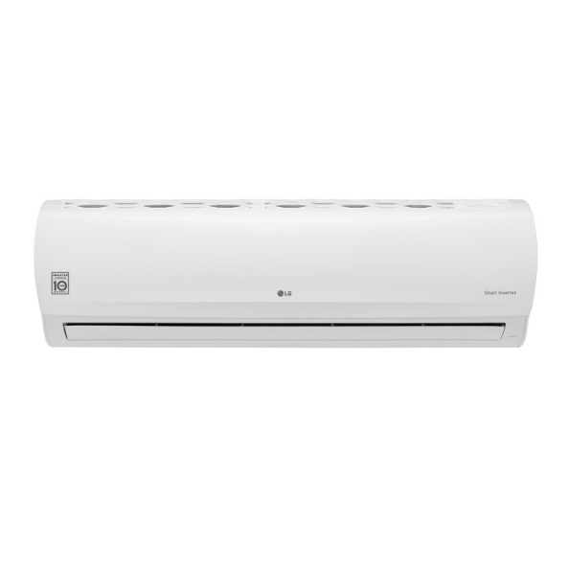

|  |  |
| --- | --- |
| **Air Flow Rate - Cooling, Max / H / M / L(㎥/min)** | 33 / 30 / 26 / 23 |
| **Sound Pressure Level - Cooling, Max / H / M / L / SL(dB(A))** | - / 53 / 49 / 44 / - |
| **Dimensions (W × H × D) - Net(mm)** | 1190 × 346 × 265 |
| **Dimensions (W × H × D) - Shipping(mm)** | 1265 × 432 × 335 |
| **Weight - Net(kg)** | 17.3 |
| **Weight - Shipping(kg)** | 21.9 |
| **Exterior Color Code** | Munsell 7.5BG 10/2 (RAL 9016) |
| **Air Flow Rate - Max(㎥/min)** | 70.0 |
| **Sound Pressure Level - Cooling, Rated(dB(A))** | 59 |
| **Dimensions (W × H × D) - Net(mm)** | 950 × 832 × 330 |
| **Dimensions (W × H × D) - Shipping(mm)** | 1065 × 918 × 461 |
| **Weight - Net(kg)** | 66.4 |
| **Weight - Shipping(kg)** | 74.2 |
| **Max. Fuse Size(A)** | 25 |
| **Exterior Color Code** | Munsell 9.54Y 8.34/1.31 (RAL 9001) |
| **Operation Range - Cooling(℃ DB)** | -5 ~ 54 |